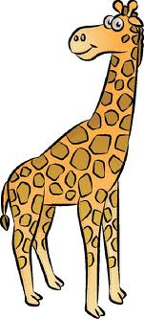
Classifying

Biologists are able to group similar animals together by studying the structures and functions of animals and looking for common features. When a biologist collects all the information about the structure and function of a specific animal or a new animal, then it can be identified and grouped with other animals of the same type.

Scientists have observed over a million different types or species of living things which can be called animals. These can be as different as a jellyfish and a snail, or a mosquito and an elephant.

Highlight the following words and find the meaning.

1. Similar ________________________________________________________________

2. Structure ______________________________________________________________

3. Function _______________________________________________________________

4. Common ______________________________________________________________

5. Specific _______________________________________________________________

6. Observed ______________________________________________________________

After something is classified into a kingdom it is separated into different groups depending on its structure and function. The groups go as follows:
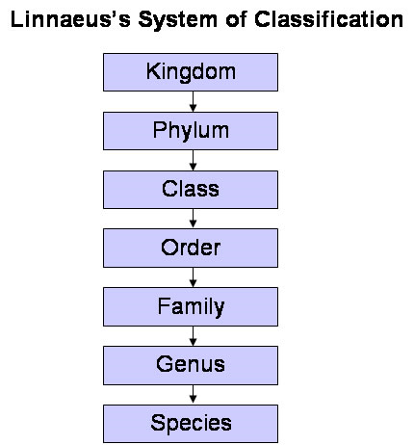

Remember Humans

_____________ ____________

_____________ ____________

_____________ ____________

_____________ ____________

_____________ ___________

_____________ ___________

_____________ ____________ Animals are in the Kingdom Animalia, Phylum Chordata and Sub-Phylum Vertebrata.

Vertebrata has 5 classes in it:

Group |  | Example | Body Covering
Mammals

Reptiles

Birds

Amphibians

Fish | Bony
 | Cartilaginous





